

**UNITED STATES DEPARTMENT OF STATE**

**OFFICE OF THE COORDINATOR FOR COUNTER-TERRORISM (S/CT)**

**PROJECT MANAGEMENT SYSTEM**

**USER MANUAL**

Compiled for S/CT by Management Systems International

Table of Contents

Table of Figures 2

Introduction 3

Welcome 4

Accessing the PMS 5

PMS Overview 6

Workload Summary 6

Approval Status 6

Admin / User 6

Using the PMS 7

Submitter 8

Overview 8

PMS Workflow 8

Program 11

Overview 11

Application Review 11

AM/CN Approval 12

Funding/Implementation Mechanism 13

Obligation Status 13

Legal 15

Overview 15

Application Review 15

AM/CN Approval 16

Funding/Implementation Mechanism 16

Obligation Status 16

Budget 17

Overview 17

Application Review 17

AM/CN Approval 17

Funding/Implementation Mechanism 18

Obligation Status 20

S/CT Manager & DAS 21

Overview 21

User Admin 22

Overview 22

Managing User Accounts 22

Managing Roles 23

Appendices 25

Appendix A: SCT User Roles and Permissions 26

Appendix B: Sample Proposal Application 26

Part 1 27

Part 2 28

# Table of Figures

Figure 1 Login form 5

Figure 2 login error 5

Figure 3 Workload summary page for submitters – this submitter has nothing in the workload summary 8

Figure 4 Showing a saved draft proposal application 8

Figure 5 Project owners 9

Figure 6 Proposal Review Buttons 12

Figure 7 Workload summary example 12

Figure 8 am/cn tab 13

Figure 9 obligation status 14

Figure 10 application review 15

Figure 11 am/cn tab, focusing on legal's action 16

Figure 12 cn clearances budget aquires outside the pms 17

Figure 13 congressional approval fields 17

Figure 14 bureau transfer clearance required 18

Figure 15 grant clearances required 19

Figure 16 MOU/IAA Clearances Required 19

Figure 17 example obligation status page showing budget actions 20

Figure 18 user admin role's home page showing user management options 22

Figure 19 options for managing an existing user 23

Figure 20 options for managing user roles 24

# Introduction

## Welcome

Please read this introduction before proceeding to the manual.

The State Counter-Terrorism (SCT) Project Management System (PMS) is built to accept and process funding requests (proposals) submitted to SCT. The PMS codifies the workflow involved in accepting and approving proposals into discrete steps split between defined user groups. Each group has a specific set of actions that can and must be performed for a proposal to be fully processed and ultimately funded. This manual will describe each user group’s actions in the process.

This manual is organized by user group; a summary of PMS user groups and the actions permitted to each group is in Appendix A, SCT User Roles and Permissions. Each section of the manual steps through each user group’s actions, in the order they are to be completed.

*Please note*: Some steps are different depending on previous action taken. This manual presents all possible permutations.

When a user group requires the action of another group before proceeding, the precedent action is noted.

Finally, if you have any issues with the PMS that this manual does not address or encounter system errors, please submit your question via email to [CTPrograms@msi-inc.com](mailto:CTPrograms@msi-inc.com) (CTHelp).

## Accessing the PMS

Accessing the PMS requires a username and password. To request a username send an email to CTHelp.

Once you receive your username and password, you can log in to the PMS at this URL: <https://www.CTPrograms.com>

The login page looks like this:

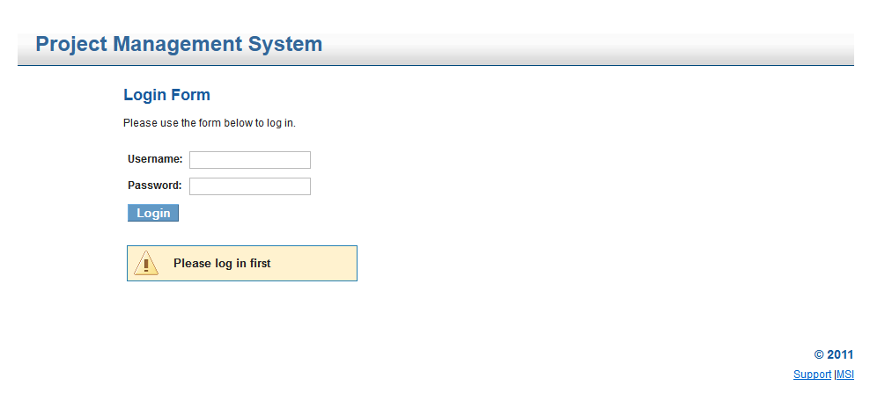

Figure Login form

If you incorrectly enter your username or password, you will be prompted to try again:

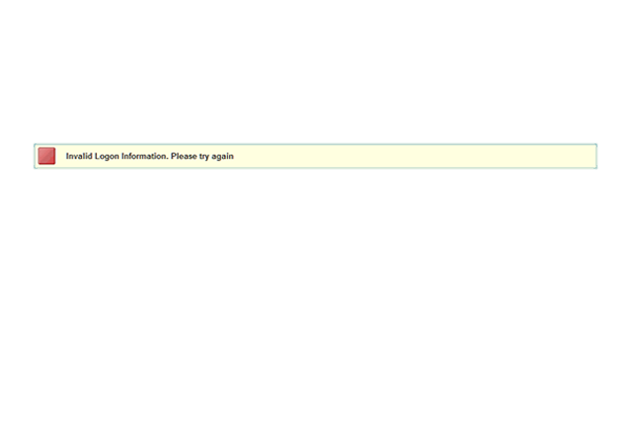

Figure login error

If you forget your password, email [CTPrograms@msi-inc.com](mailto:CTPrograms@msi-inc.com) with your username to request a new password.

## PMS Overview

Once logged in to the PMS, depending on your role you will see all or some combination of 4 tabs: Workload Summary, Approval Status, Reports and User/Admin.

### Workload Summary

The Workload Summary page displays all proposals currently in the PMS that are relevant to the logged in user. Proposals at different steps in the process are grouped under descriptive headings in the workload summary. This provides users with a dashboard of the current tasks awaiting their attention. See the submitter’s Workload Summary page section for example figures.

### Approval Status

The Approval Status page displays all proposals that are currently in the PMS for the user’s program where applicable. Legal, budget and DAS/manager user groups view all proposals that have been submitted in the PMS from all programs, but Submitter, Program and Submitter/Program see only proposals that have been submitted to that program (e.g. RSI, ATA, CVE, etc.). Any user with access to this page can click on a proposal to view its detailed information.

Users can also perform actions on relevant proposals accessed from the Approval Status page just as if they had accessed them from the Workload Summary page (the detail tabs of a proposal will still only display the information that is relevant to a user’s role):

* **Submitter** – has read-only access to the details of the proposals the user has submitted
* **Program** – can perform all necessary approvals, document uploads, and viewing of proposals in user’s assigned program
* **Submitter/Program** – combines both Submitter and Program access and roles into one.
* **Legal** – can see all proposals in all programs, can pre-clear proposal, clear CNs & Funding/Implementation Mechanisms
* **Budget** – can see all proposals in all programs, can clear CNs & Funding/Implementation Mechanisms, and update obligation status
* **SCT Manager/DAS** – can see all proposals in all programs excepting un-submitted drafts saved by a submitter.

### Admin / User

Admin-level users have a tab labeled “Admin”. The admin tab is described in the User Admin section below.

Non-admin users have a tab called “User”. Clicking on this tab opens a page that allows the user to update his/her name or change his/her password.

# Using the PMS

## Submitter

### Overview

The submitter user group (submitter) accesses the PMS to submit proposals. The submitter may also need to revise proposals if the program user group requests modifications to a submitted proposal. The submitter is usually the entity seeking funding, but proposal submission may also be performed by the submitter/program user group if a submitter is unable to access the PMS.

### PMS Workflow

#### Workload Summary Page

Upon successful login, the submitter views the workload summary page:

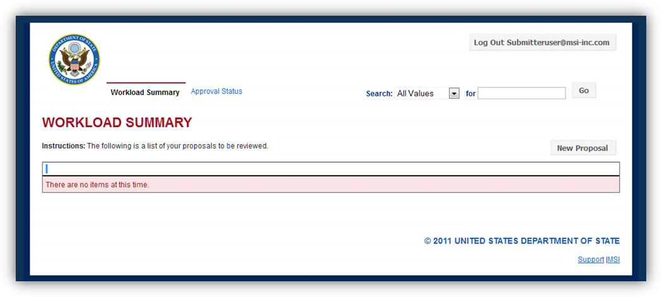

Click here to log out at any time.

New Proposal Button

Figure 3 Workload summary page for submitters – this submitter has nothing in the workload summary

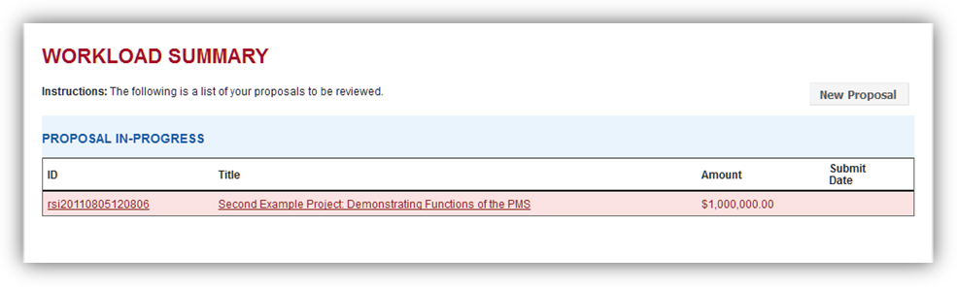

Figure Showing a saved draft proposal application

The workload summary lists proposals that are currently being worked on or require attention by the user. To begin a new proposal application, click the new proposal button (see Figure 3).

#### Create a New Proposal

Each of these numbered steps corresponds to a line in the proposal application form (application). All fields marked with an asterisk (*) are required fields. The application cannot be submitted for approval unless all required fields are completed (See Appendix B for a sample proposal Application):

##### 1.* Project Owners

“Add Project Owner” button. Click to add another row. Same functionality is seen later in “Add Implementer”, “Add Budget Item”, “Add Objective & Indicator”, and “Add Document” buttons.

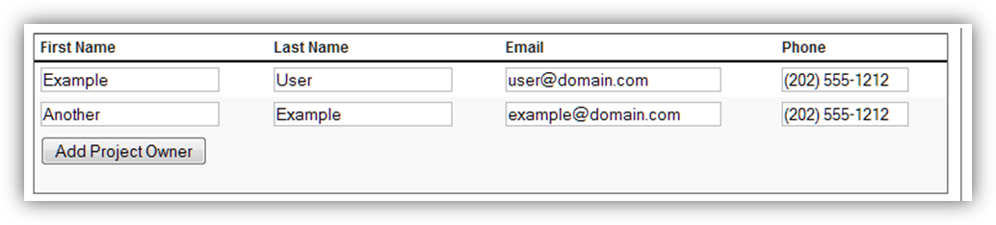

Figure Project owners

List the required information for the individuals who will own this project for the entity requesting the funds. The default is for a single owner, but to add more click the “Add Project Owner” button to add another row (see Figure 5)

##### 2. *Project Title

Enter the title of the proposed project.

##### 3. *Project Objective(s)

List all objectives this project is meant to achieve. The response is limited to 500 characters.

##### 4. *Description of Program Proposed

Provide a 1000 to 4000 character description of the program for which funding is sought.

##### 5. *Specify explicitly how this proposal advances US national security and foreign policy interests

##### 6. *Specify explicitly how this activity supports law enforcement's ability to counter terrorism

##### 7. *What have the sponsors of the project done to coordinate this program with this interagency or multilateral partners? (What offices/agencies have been consulted. How did you ensure this is not duplicative?)

(5-7 are self-explanatory)

##### 8. *Time Frame for Implementation

Enter the proposed start and end dates for the program in MM/DD/YYYY format.

##### 9. Place of Implementation

Choose between Not Country or Region Specific, Specific Countries, or Regional options. For either of the latter 2, select the country(ies) or region(s) in which the program will operate.

##### 10. Implementer Information

Enter the requested information about the organization(s) that will be implementing the program described above. The “Add Implementer” button is used to add additional fields for more than one implementer.

##### 11. Program Audience

Enter the people who will be the recipients of this program’s actions.

##### 12. *Funding Amount Requested

Enter the whole US dollar amount (no commas, decimal points, or dollar signs) that this program is requesting for implementation.

##### 13. Funding Breakdown

Provide a line-item breakdown of how the program plans to spend the requested funds, per country of implementation. The “Add Budget Item” button is used to add additional lines to this item.

##### 14. *Funding/Implementation Mechanism Type

Select the method by which the implementers will receive the funds requested.

##### 15. Objectives & Indicators

Listing no more than 2 lines enter the objective(s) and indicator(s) that will be used to measure the progress of this program if it is implemented. Use the “Add Objective & Indicator” button to add the second line if needed.

##### Attach Documents

Attach any supplementary documents that you feel are necessary for the proposal. Include a short description of each document uploaded so reviewers know what each document contains as the application is processed. . The “Add Document” button is used to add fields for additional document uploads.

##### Final Step

At the bottom of the application are two buttons “Save” and “Submit Proposal for Review”. The “Save” button allows the submitter to save draft and return to the unfinished application at a later date to finish entering information for submission. When all the necessary information has been entered the submitter clicks “Submit Proposal for Review” to submit the proposal and move it into the next stage of the workflow, Proposal Review.

## Program

### Overview

Program users (program) own the proposals as they move through the PMS. Program is the user that communicates with all entities both internal and external to the PMS. Program has a role to play at each step in the process, and at times will even submit proposal applications. Upon successful login, Program will see the workload summary page, with all relevant proposals currently in the PMS, with proposals grouped by their progress. Clicking on a proposal will take the user to the application review page.

### Application Review

Even before a proposal is pre-cleared by legal, program can review the application, send to Legal and read comments from legal requiring some action taken, and can also submit comments (back) to legal.

Program reviews the application and its numbered form fields on the Application review tab. The proposal application can be collapsed by clicking the “Collapse” link at the top of the application, and expanded back to full visibility by clicking “expand” (see figure 10). Program must also set the Funding Source by clicking the “Edit Proposal” button, found at the bottom of the Application Review page, navigating to #16 “Funding Sources”, and choosing the source(s) of funding for the proposal. This must be done before sending the proposal to Legal for pre-clearance.

If necessary program will require the submitter to make changes to the application and re-submit it, or program can choose to make those changes by clicking the “Edit Proposal” button, found at the bottom of the Application Review page. Once on the edit application page, program can send the application back to the submitter by clicking the appropriate button at the bottom right of the form.

After Legal has pre-cleared the proposal, program conducts a review of the proposal and can perform one of the following actions, which are done via buttons at the bottom of the Application Review page (see figure 6):

#### Hold Proposal

This “pauses” the proposal, allowing for the proposal to proceed at a future time when it will make more sense.

#### Deny Proposal

The submitter is notified that their proposal has been denied by S/CT. This ends the processing of this proposal and no further action is required by any user.

Send Proposal Back

Program requires the submitter to make changes to the application and re-submit it.

#### Edit Proposal

Program uses this button to make changes to the content of an application prior to approval.

#### Approve Proposal

When program is satisfied with the application’s content, program approves the application and the proposal then enters the AM/CN Approval phase.

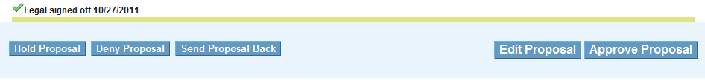

Figure Proposal Review Buttons

### AM/CN Approval

Approved proposals are next visible in the Workload Summary as “Proposal Awaiting AM/CN to Budget”, as seen in this figure:

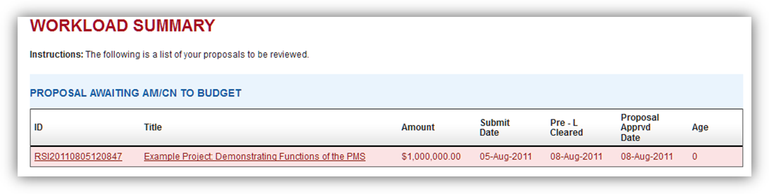

Figure 7 Workload summary example

Clicking on the proposal opens the proposal detail at the Review tab. Click the AM/CN tab to perform the functions on that page:

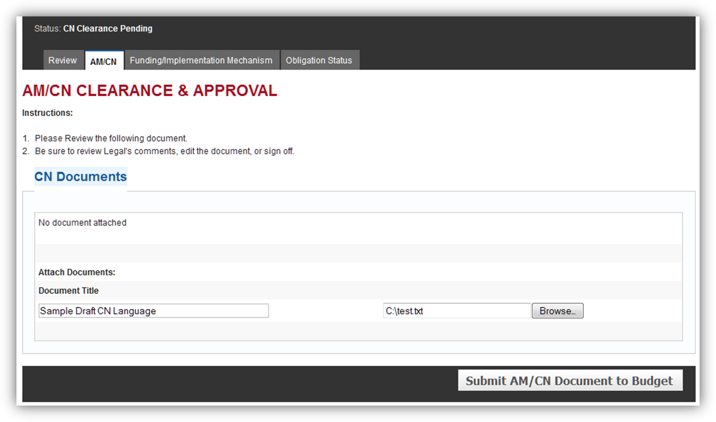

AM/CN Tab

Send to Budget

Upload CN document

Figure 8 am/cn tab

CN Documents are compiled outside the PMS. The completed draft CN is uploaded to the PMS by Program by entering a Document Title, clicking the “Browse…” button, and then clicking “Submit AM/CN Document to Budget”. At this point the document is uploaded and the proposal is visible in Budget’s Workload Summary and Budget begins its work in the PMS.

### Funding/Implementation Mechanism

There are 5 sections on this page. Depending on which Funding/Implementation mechanism is chosen by budget, the contents of the “Funding/Implementation Mechanism Clearance Update” section will change, or the section may be hidden. Program’s only actions on this page are to upload and view uploaded documents related to the funding/implementation mechanism process.

### 

### Obligation Status

Program can upload and view uploaded obligation documents, as well as view the obligation amounts that have been entered by budget.

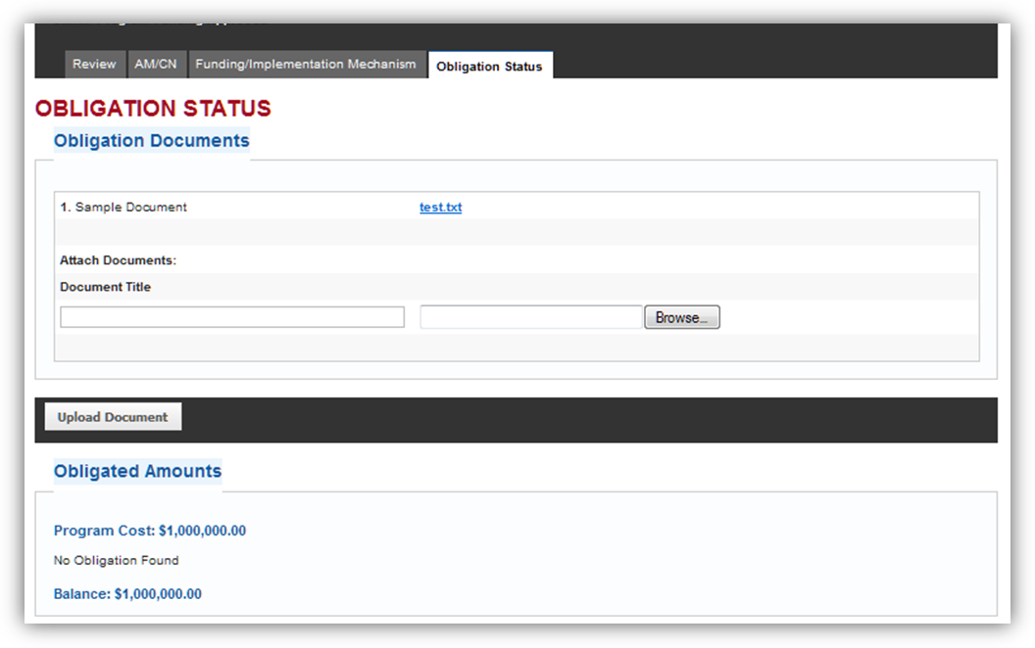

View & Upload Obligation Docs

View Obligation amount(s)

Figure 9 obligation status

## Legal

### Overview

The Legal user group (legal) is responsible for verifying the legality of a submitted proposal, and of the language of the Congressional Notification or MOU/IAA documents that are later submitted to Congress.

Submitted proposals are added to legal’s workload summary for Pre-Clearance as “Proposal Review Pending”. Clicking on a submitted proposal opens the Application review tab of the detail view of the proposal.

### Application Review

Legal reviews the application and its numbered form fields on the Application review tab. The proposal application can be collapsed by clicking the “Collapse” link at the top of the application, and expanded back to full legibility by clicking “expand” (see figure 10).

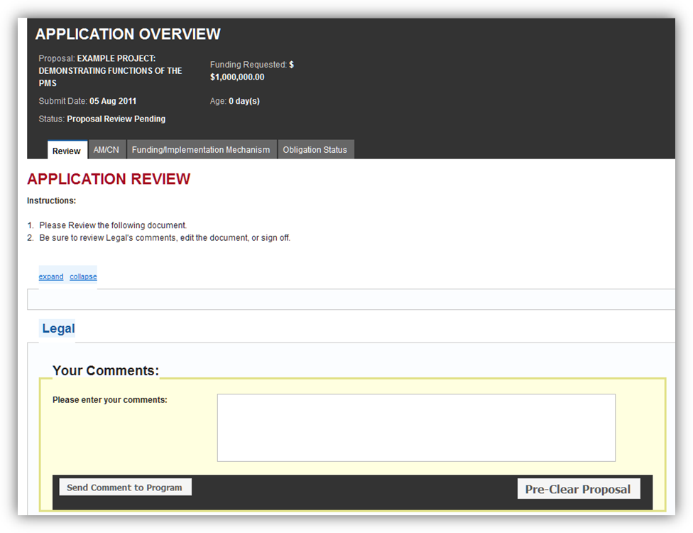

Expand/collapse application

(application currently hidden)

Pre-Clear Proposal

Comments to Program Users

Figure application review

After reviewing the proposal application, legal can submit comments (See figure 10) seeking clarification of specific points. These comments are read by Program users. Via these comments legal can also require that the submitter make changes to the proposal before it can be pre-cleared.

When legal is satisfied that the submitted application meets all criteria, the Pre-Clear Proposal button is clicked and then Program Users take the next steps.

### AM/CN Approval

Legal must review and clear the CN language that is uploaded by program. Approval is noted by changing the “Legal (L)” status under the “CN Clearance Update” header to either Yes or No. Budget will have set this to “Pending” first, which will make the proposal appear in legal’s Workload Summary. Legal will also provide a brief statement regarding the selection in the text box to the right of the selection. The proposal cannot be sent for Congressional Approval until legal has cleared the draft CN language.

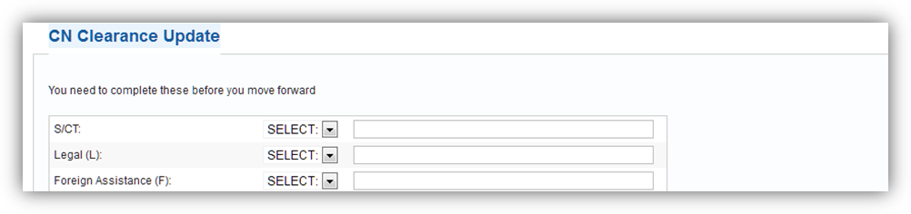

Legal (L) CN Clearance

Figure am/cn tab, focusing on legal's action

### Funding/Implementation Mechanism

Legal’s only action on this page is to provide clearance for proposals that are to be funded via an MOU/IAA. When budget sets Legal (L)’s clearance status to “Pending”, the proposal appears in legal’s Workload Summary. Legal clicks on the proposal and navigates to the Funding/Implementation Mechanism tab to provide its approval in the same manner as was done in the previous AM/CN Approval phase.

Legal’s role in the PMS ends with this phase.

### Obligation Status

Legal has no role in this phase of the proposal.

## Budget

### Overview

The budget user group (budget) is responsible for processing proposals through CN and Funding clearances, working with program and legal to complete the steps necessary to fund approved proposals.

### Application Review

Budget has no role in this phase of the proposal, but can view the proposal application on this tab and see when Legal Pre-Cleared the proposal.

### AM/CN Approval

To achieve AM/CN approval, budget must seek the approval of the draft CN language uploaded by program by several agencies (see figure 12). Legal will enter its clearance of the CN language after budget sets the status for legal (L) to “Pending”, but budget must update these clearances to Yes/No for all other agencies. The proposal cannot continue beyond this step until all clearances are obtained. 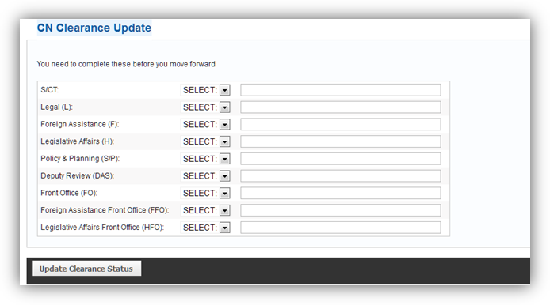

Must be set to Pending before (L) can see the proposal.

Figure cn clearances budget aquires outside the pms

When all clearances have been obtained, the proposal receives a CN# and is sent to the hill for approval. The status of Congressional Approval is tracked at the bottom of this tab (see figure 13). The proposal cannot continue on to the Funding/Implementation Mechanism phase until Congressional Approval has been given. Do not attempt to set the CN Approval Status to “Approved” before all clearances (above) are obtained! 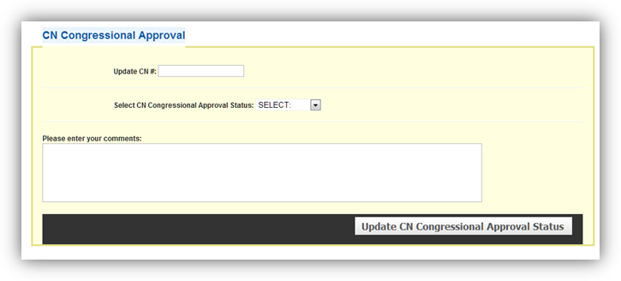

Only set this to Approved when all Clearances have been received.

Figure congressional approval fields

### Funding/Implementation Mechanism

There are 5 sections on this page. Depending on which Funding/Implementation mechanism is chosen by budget, the contents of the “Funding/Implementation Mechanism Clearance Update” section will change, or the section may be hidden.

#### Funding/Implementation Mechanism Type

This allows budget to change the type as necessary between Bureau Transfer, Fund Cite to Post, Grant, or MOU/IAA.

#### Funding/Implementation Mechanism Documents

All documents that are required to be completed in support of the chosen mechanism are uploaded here. Program can also upload and review documents uploaded here.

#### Budget Funding Request

This is the date that the budget funding request was initially made.

#### Funding/Implementation Mechanism Clearance Update

This section will change depending on the mechanism chosen:

##### Bureau Transfer

Only Budget must clear a bureau transfer:

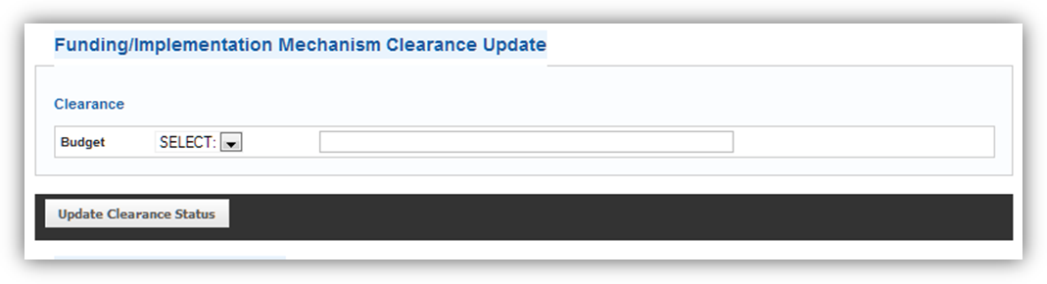

Figure bureau transfer clearance required

##### Fund Cite to Post

No clearance is required for a fund cite to post.

##### Grant

Grants require 7 different approvals. Budget obtains all of these outside the PMS:

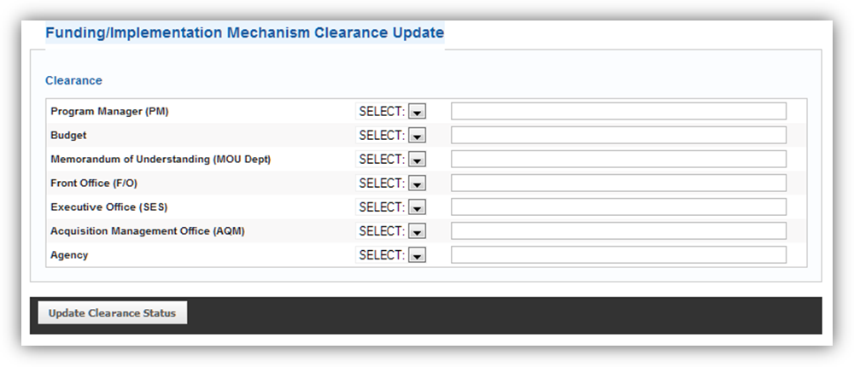

Figure grant clearances required

##### MOU/IAA

An MOU/IAA requires 8 different approvals. Budget obtains all of these outside the PMS excepting Legal, who has to log in and provide clearance after budget sets Legal (L)’s status to “Pending”: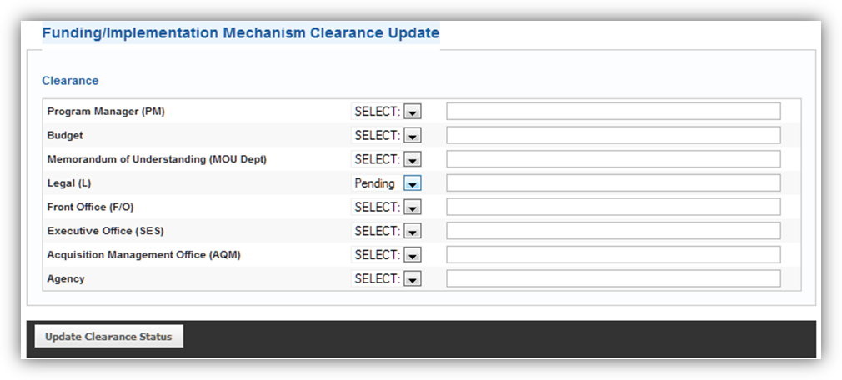

Must be set to Pending before (L) can see the proposal.

Figure MOU/IAA Clearances Required

#### Budget Funding Approval

This is the date that the final funding approval was granted by budget. This is the final piece of information to be entered for this phase of the proposal. Once all required documentation and necessary clearances have been obtained budget can enter this date and click “Save & Complete Funding/Implementation”. The proposal is then ready for the Obligation Status phase.

### Obligation Status

There are 2 sections to the Obligation Status tab: Obligation Documents and Obligated Amounts. Budget can upload and view uploaded documents in the first section. Program also has access to this action. Budget also enters additional obligated funds that are provided to the proposal (now a project), which can be viewed but not modified by program or DAS/manager users.

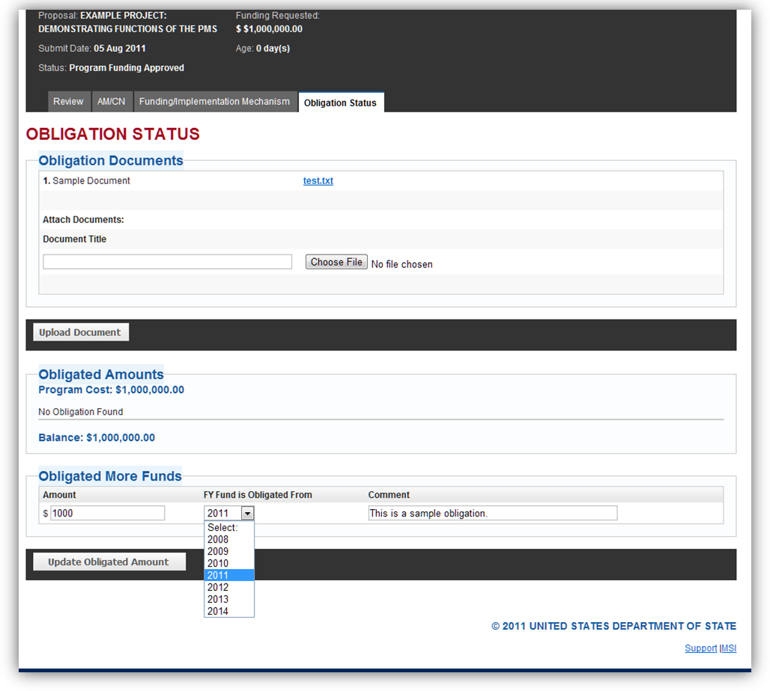

Enter additional funds obligated. Actual obligation occurs external to the PMS.

Figure example obligation status page showing budget actions

## S/CT Manager & DAS

### Overview

The S/CT Manager and DAS user groups (manager) views proposals that have been submitted to the PMS. Managers can perform no actions with the proposals, but they can view all proposals currently in the PMS.

As the manager has no workload, the Workload Summary tab does not appear. The Approval Status tab is present, allowing the manager to get a quick overview of which proposals are at which stage in the approval process.

The manager can click on any proposal to view the detailed information on that proposal that is in the PMS.

## User Admin

### Overview

The user admin group (admin) manages the user accounts and the roles assigned to each of those users in the PMS. The admin sees the admin tab on successful login. If the user is only an admin, only the admin tab will be visible. The admin tab has 3 buttons: “Add User”, “Users”, and “roles” (See Figure 18). Clicking the Admin tab at any page will return you to the Admin tab “home page”, but please note that any unsaved form data will be lost by doing this.

This section of the manual first addresses user account creation and maintenance, and then addresses management of roles.

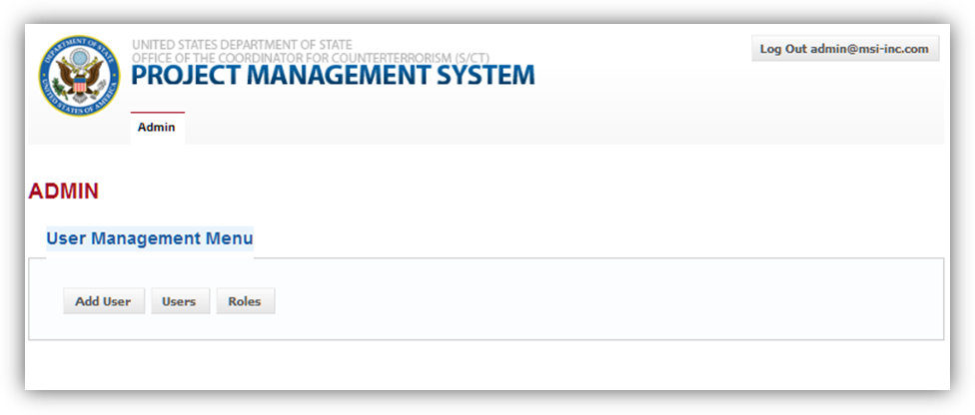

User Management options

Figure user admin role's home page showing user management options

### Managing User Accounts

#### Creating a New User Account

To create a new user account, click the “Add User” button. This displays the User Details form:

##### Full Name

Enter the full name for the user

##### Password/Confirm Password

Enter a password for the user to use at login here, and re-enter it to confirm that is was entered correctly. Remember this value, you’ll need it to provide to the user later.

##### Email

Enter the user’s email address. This is the also the username for this user.

##### Description

Provide a description of the user as necessary.

##### Program

The SCT Program for which the user works. Only users who are added to the submitter or program roles should have an assigned SCT Program. Other users (budget, legal, manager) are not assigned to a Program.

Available Roles

These are the different roles that can be applied to this user. Only one role can be applied to a user. Roles can be modified with different permissions, see Managing Roles for more information.

When the new user information has been entered, click the “save” button. Send an email to the user notifying them of the URL for the PMS and their password. Be sure to notify them that their email address is their username for the system.

#### Managing Existing User Accounts

To view the current list of users, click the “Users” button. The Users page lists all user accounts in the PMS along with summary identification data (see Figure 19). There are also 4 different actions that can be done to a user account from this page.

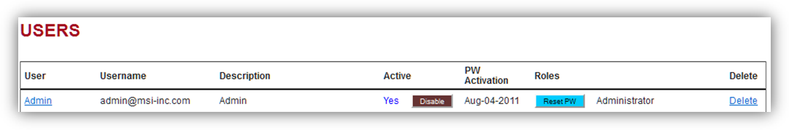

Figure options for managing an existing user

##### Click on the User’s Name (Edit User)

To edit a User’s information, click on the user’s name to show the User Details form.

##### Activate/Disable

If a user is active the “Disable” button is shown. If a user is inactive the “Activate” button is shown. Active users can log in to the PMS, Disabled users cannot.

##### Reset PW

Click the “Reset PW” button to automatically change the user’s password to a random string that will be emailed to the user’s email address.

###### Delete

Clicking delete will permanently remove a user from the PMS.

***Note: For auditing purposes it is inadvisable to ever delete a user from the PMS, unless the user never logged in.***

### 

### Managing Roles

User roles ensure that each user sees the options necessary at the proper stage for each proposal. They also prevent users from seeing options or entering information that is beyond the scope of the user’s assigned duties.

Each user is assigned to one role, and each role contains several permissions. Clicking the “Roles” button on the Admin tab home page shows the User Roles page. There are 3 actions that can be taken on the User Roles page: Add a new role, Click on a role’s name (Edit a role), and delete an existing role (see Figure 20):

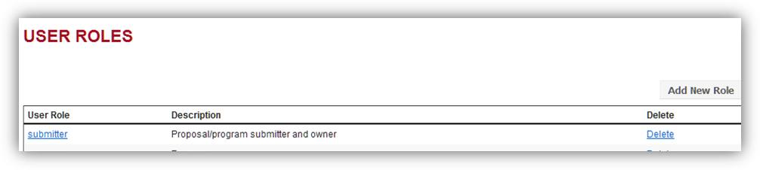

Figure options for managing user roles

#### Add a New Role

Click the “Add a New Role” button to bring up the New Role form.

##### Role

Enter the name for the new role here. Try to keep it simple, 1 to 3 words.

##### Description

Here you can enter a lengthier paragraph of information about the role.

##### Permissions

Assign a set of permissions to the role here.

After completing the form click “save”. The new role is now available to be applied to user accounts.

#### Click on an Existing Role (Edit Role)

To edit an existing role, click on the role’s name. This displays the Role form to allow edits to be made.

#### Delete an Existing Role

If it has been determined that a role is no longer necessary, you can delete that role from the PMS by clicking delete. Users in that role should be moved to a new role before this deletion to prevent any issues with their accessing the PMS.

# 

# Appendices

## Appendix A: SCT User Roles and Permissions

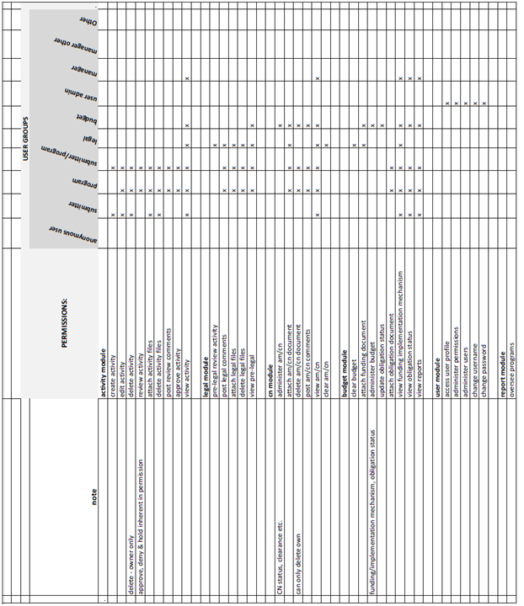

## Appendix B: Sample Proposal Application

### Part 1

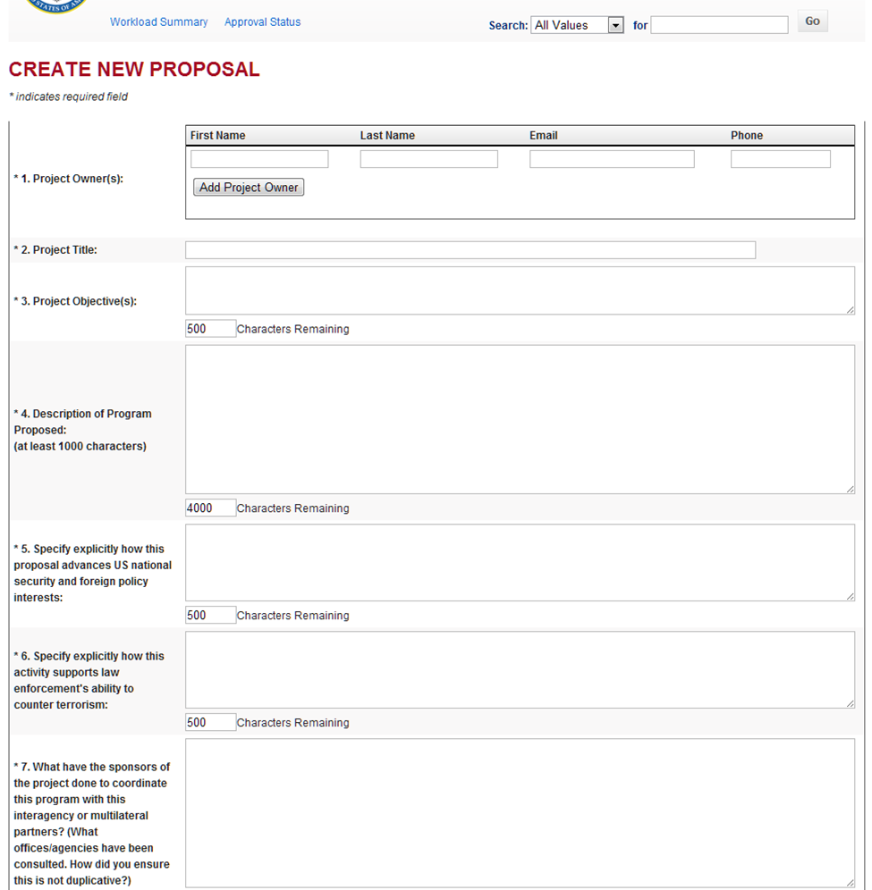

### Part 2

